Alpha amino acids
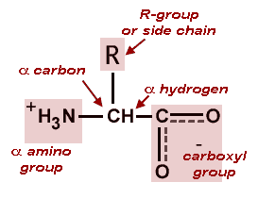or 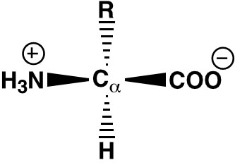

Formation of zwitterions

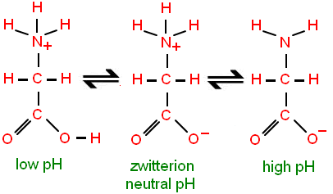

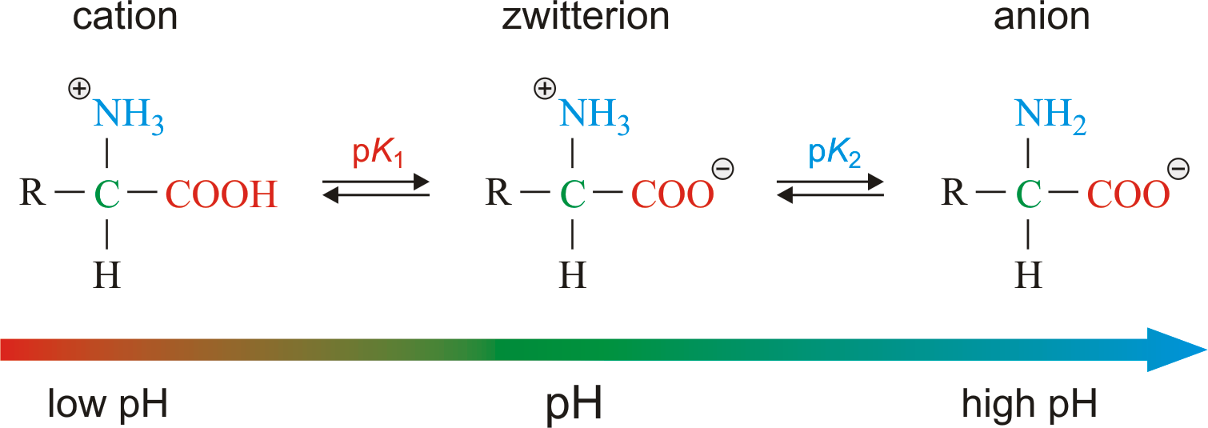
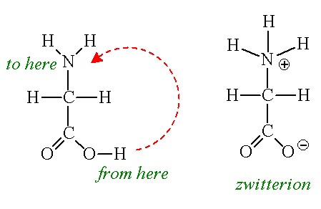
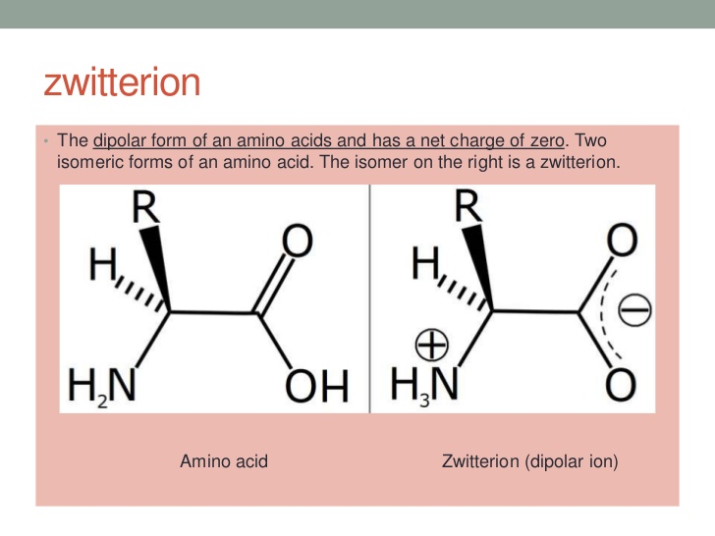
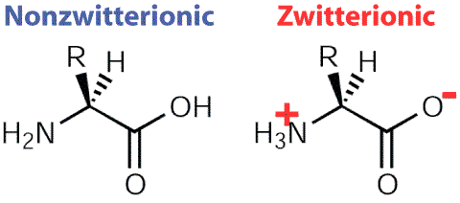
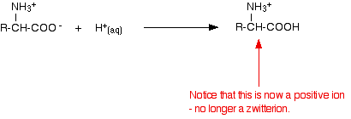
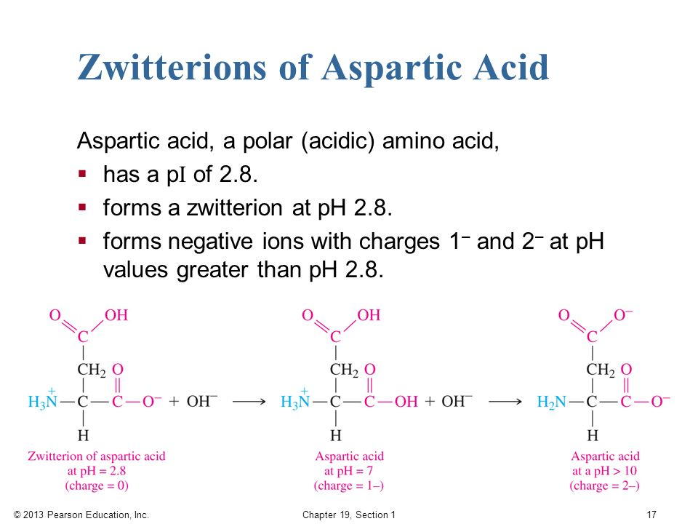
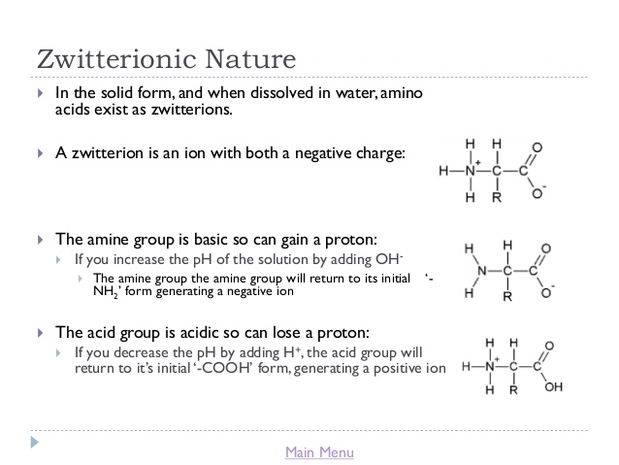

Formation of a peptide bond by the condensation of an amino acid
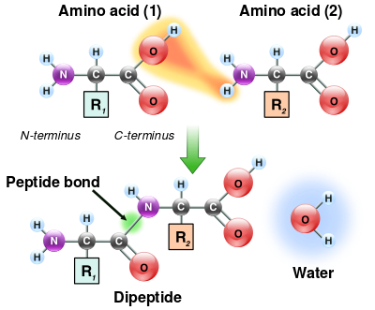

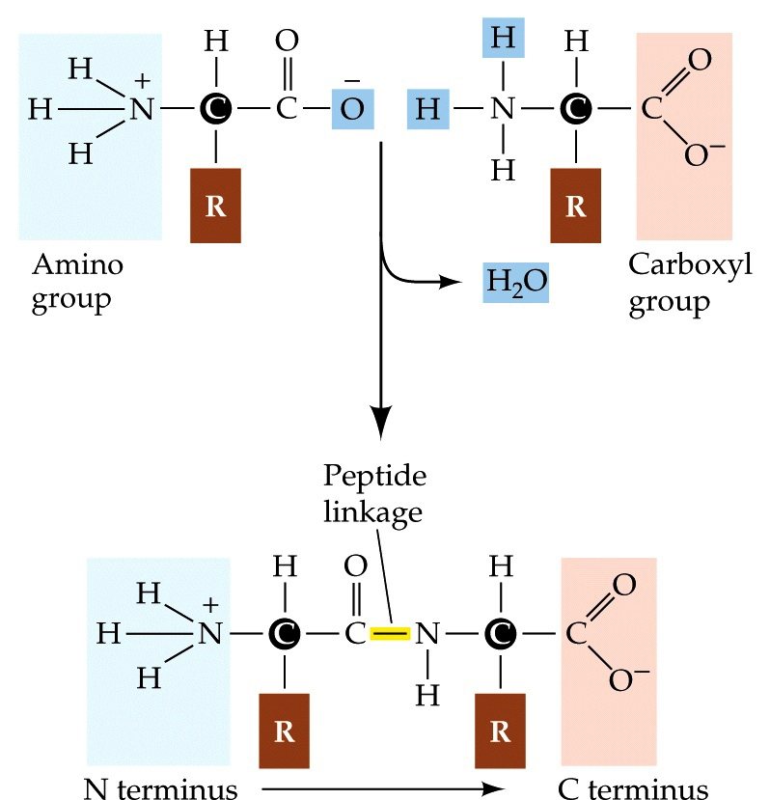

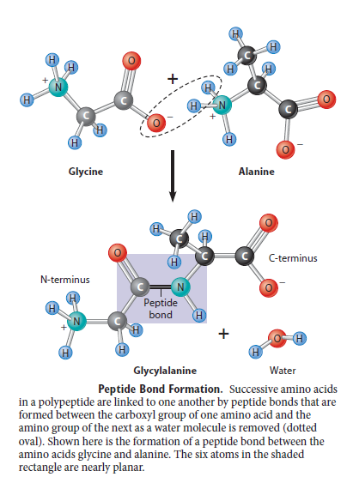

The sequence of amino acids is called its primary structure
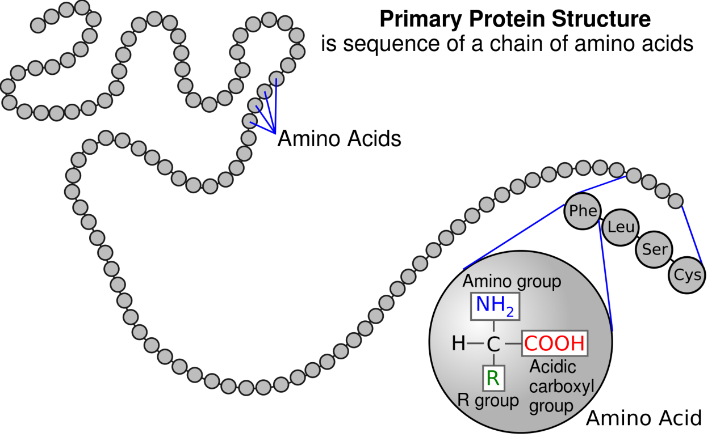
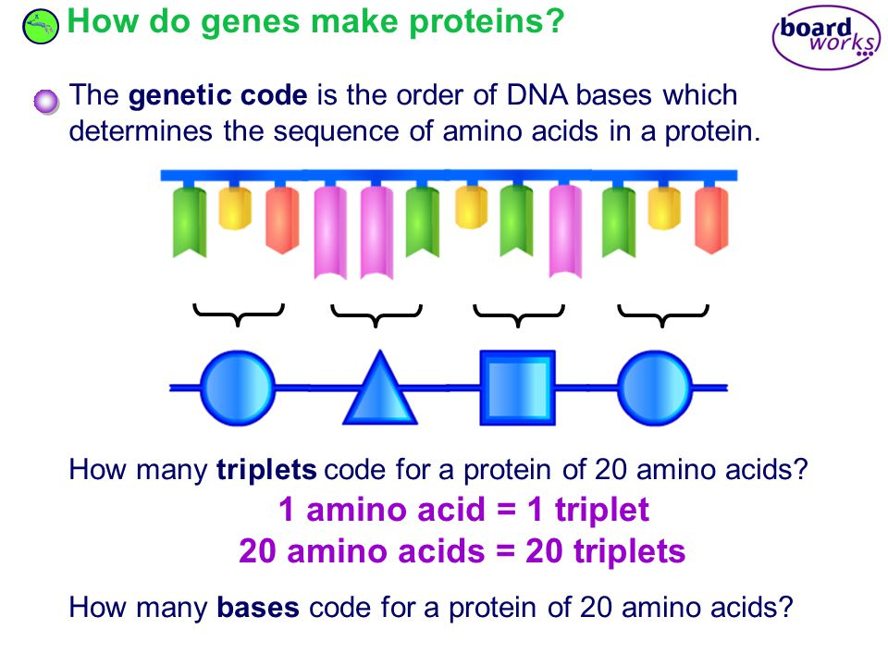

Alpha helix and beta pleated proteins
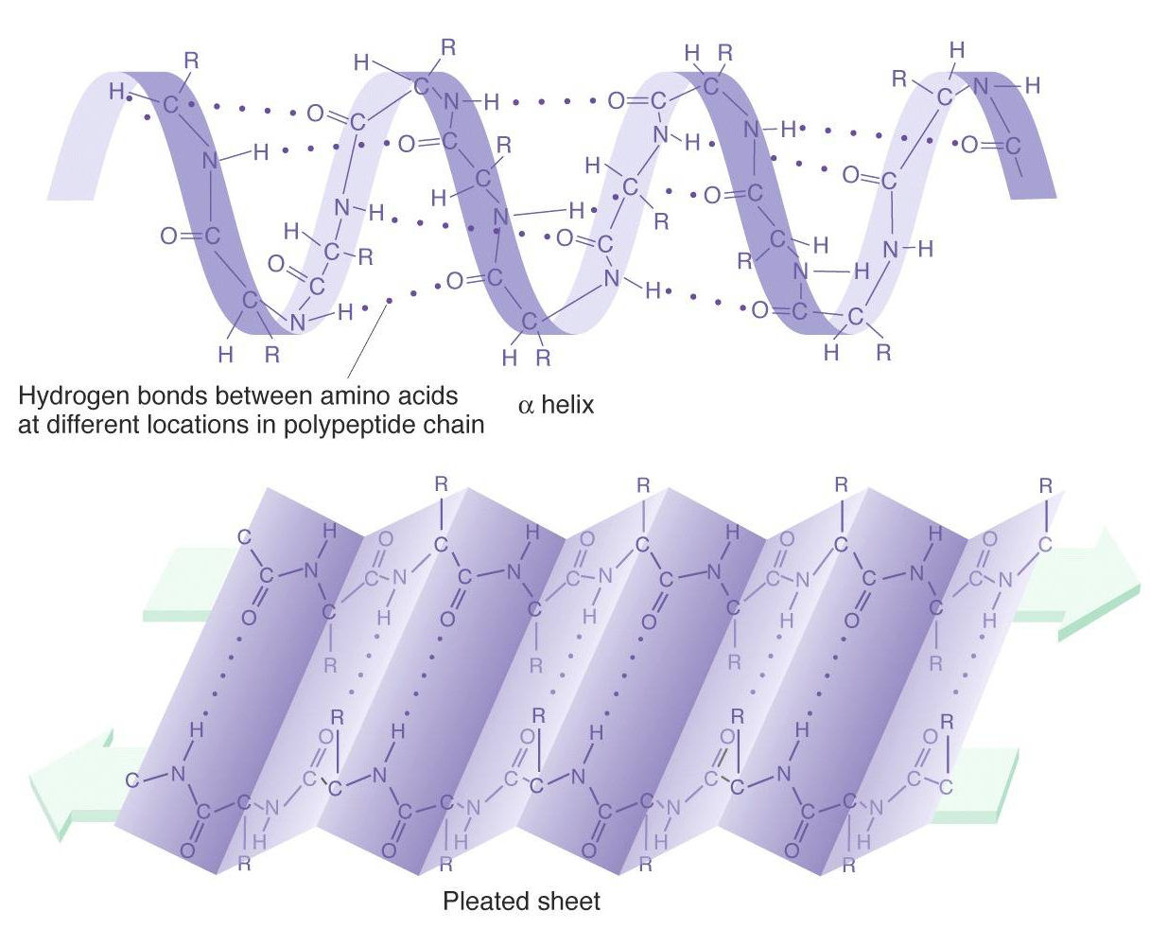
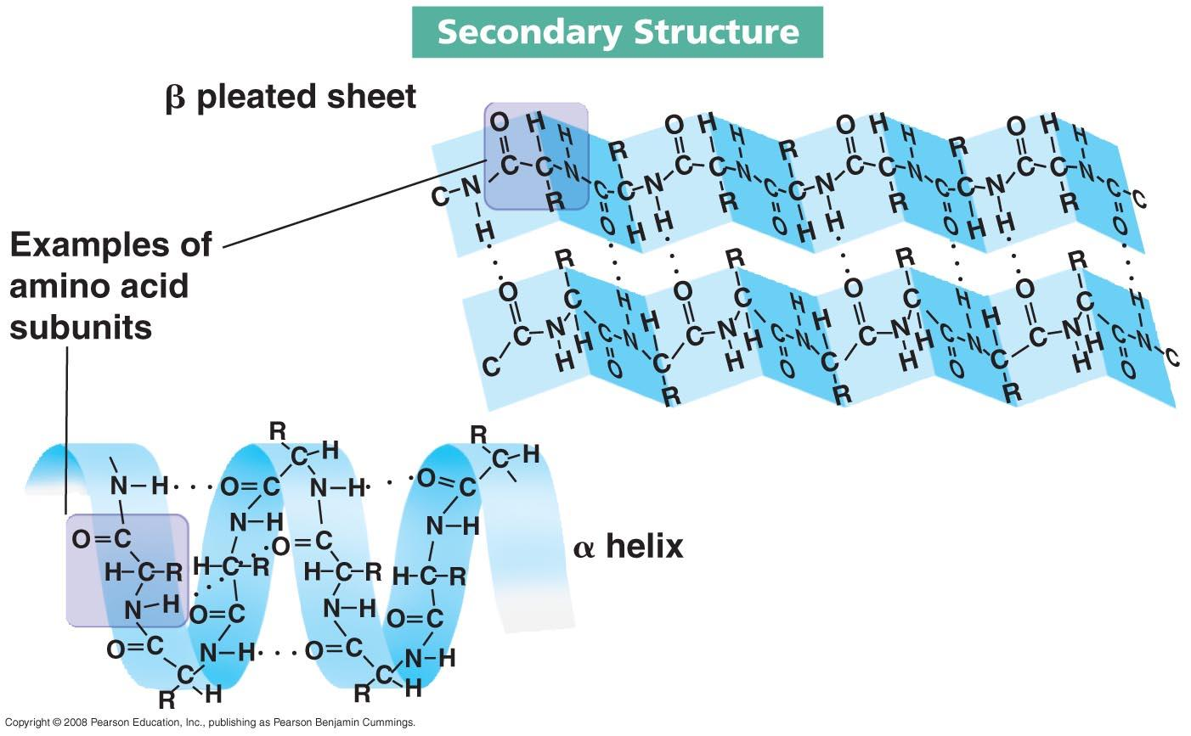
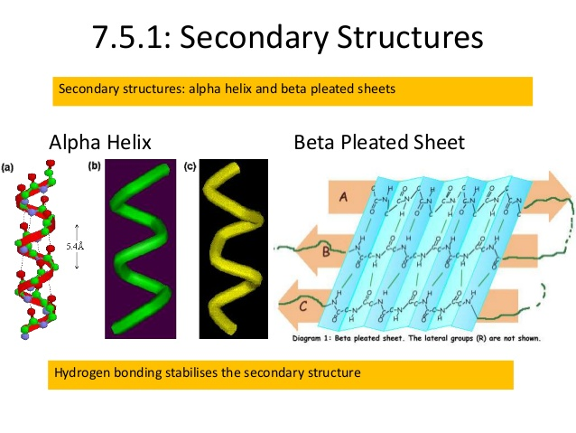
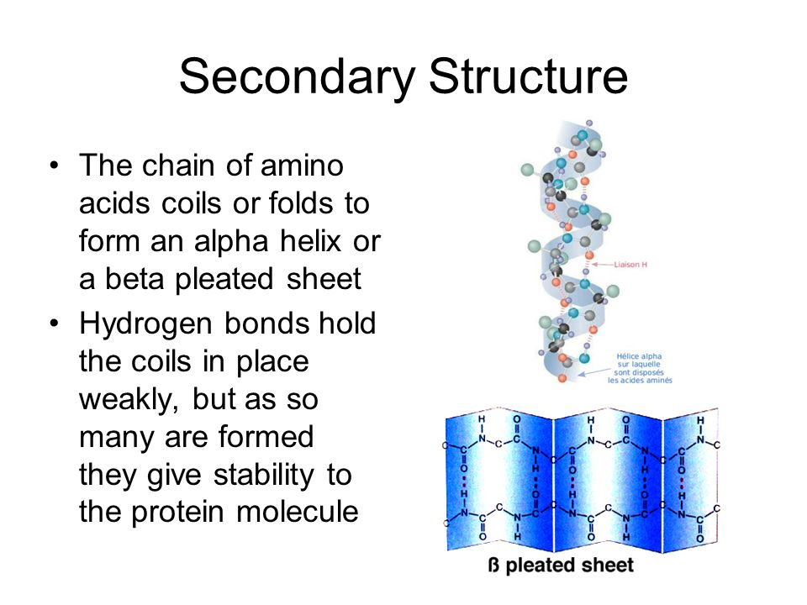
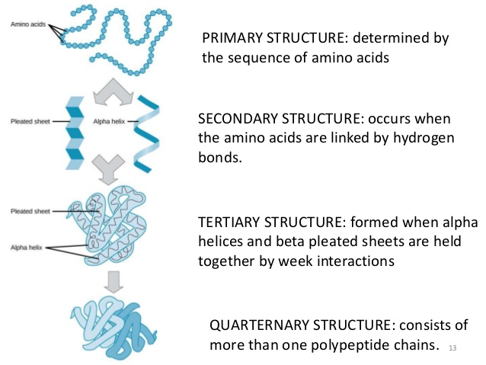

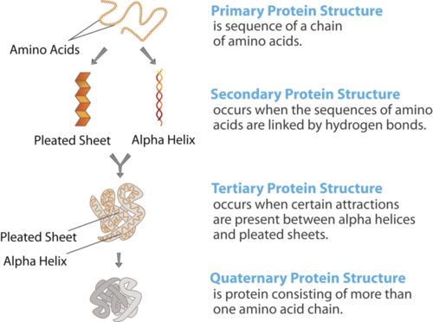

Tertiary structure of a protein
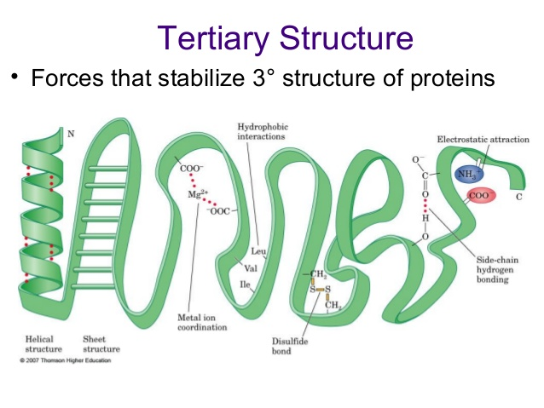
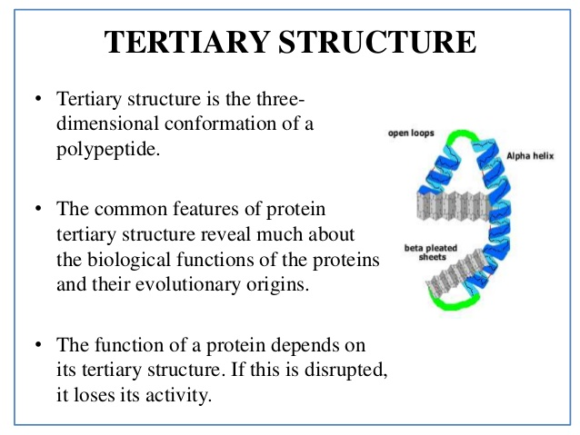

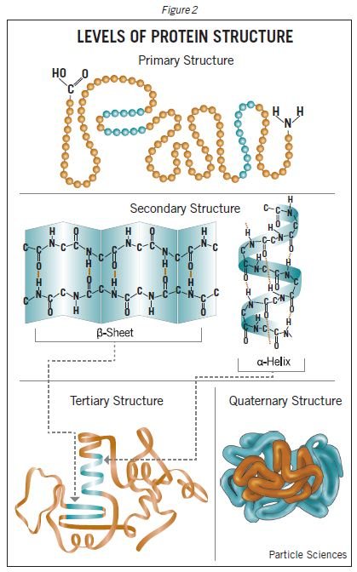

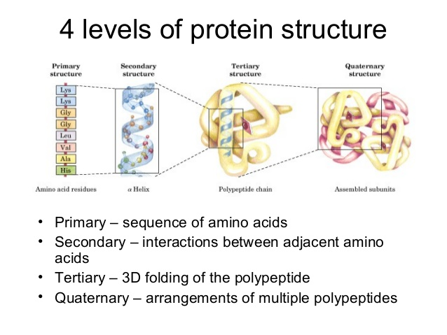
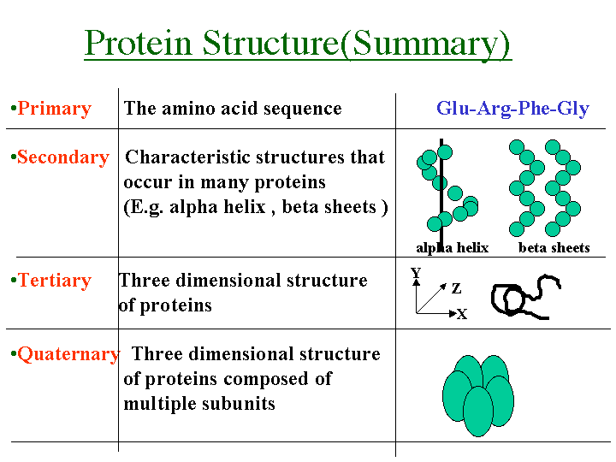

Primary Structure
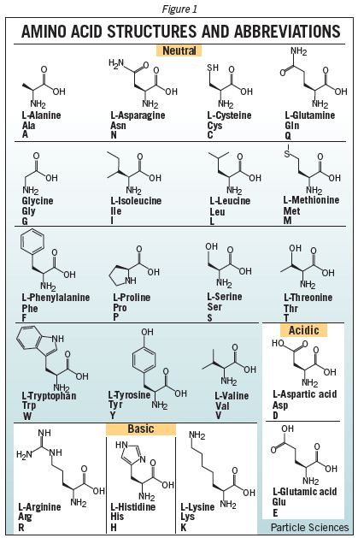
There are 20 different standard L-α-amino acids used by cells for protein construction. Amino acids, as their name indicates, contain both a basic amino group and an acidic carboxyl group. This difunctionality allows the individual amino acids to join together in long chains by forming peptide bonds: amide bonds between the -NH2 of one amino acid and the -COOH of another. Sequences with fewer than 50 amino acids are generally referred to as peptides, while the terms protein or polypeptide are used for longer sequences. A protein can be made up of one or more polypeptide molecules. The end of the peptide or protein sequence with a free carboxyl group is called the carboxy-terminus or C-terminus. The terms amino-terminus or N-terminus describe the end of the sequence with a free α-amino group.
The amino acids differ in structure by the substituent on their side chains. These side chains confer different chemical, physical and structural properties to the final peptide or protein. The structures of the 20 amino acids commonly found in proteins are shown in Figure 1. Each amino acid has both a one-letter and three-letter abbreviation. These abbreviations are commonly used to simplify the written sequence of a peptide or protein.
Depending on the side-chain substituent, an amino acid can be classified as being acidic, basic or neutral. Although 20 amino acids are required for synthesis of various proteins found in humans, we can synthesize only 10. The remaining 10 are called essential amino acids and must be obtained in the diet.
The amino acid sequence of a protein is encoded in DNA. Proteins are synthesized by a series of steps called transcription (the use of a DNA strand to make a complimentary messenger RNA strand - mRNA) and translation (the mRNA sequence is used as a template to guide the synthesis of the chain of amino acids which make up the protein). Often, post-translational modifications, such as glycosylation or phosphorylation, occur which are necessary for the biological function of the protein. While the amino acid sequence makes up the primary structure of the protein, the chemical/biological properties of the protein are very much dependent on the three-dimensional or tertiary structure.

Secondary Structure
Stretches or strands of proteins or peptides have distinct characteristic local structural conformations or secondary structure, dependent on hydrogen bonding. The two main types of secondary structure are the α-helix and the ß-sheet.
The α-helix is a right-handed coiled strand. The side-chain substituents of the amino acid groups in an α-helix extend to the outside. Hydrogen bonds form between the oxygen of the C=O of each peptide bond in the strand and the hydrogen of the N-H group of the peptide bond four amino acids below it in the helix. The hydrogen bonds make this structure especially stable. The side-chain substituents of the amino acids fit in beside the N-H groups.
The hydrogen bonding in a ß-sheet is between strands (inter-strand) rather than within strands (intra-strand). The sheet conformation consists of pairs of strands lying side-by-side. The carbonyl oxygens in one strand hydrogen bond with the amino hydrogens of the adjacent strand. The two strands can be either parallel or anti-parallel depending on whether the strand directions (N-terminus to C-terminus) are the same or opposite. The anti-parallel ß-sheet is more stable due to the more well-aligned hydrogen bonds.

Tertiary Structure
The overall three-dimensional shape of an entire protein molecule is the tertiary structure. The protein molecule will bend and twist in such a way as to achieve maximum stability or lowest energy state. Although the three-dimensional shape of a protein may seem irregular and random, it is fashioned by many stabilizing forces due to bonding interactions between the side-chain groups of the amino acids.
Under physiologic conditions, the hydrophobic side-chains of neutral, non-polar amino acids such as phenylalanine or isoleucine tend to be buried on the interior of the protein molecule thereby shielding them from the aqueous medium. The alkyl groups of alanine, valine, leucine and isoleucine often form hydrophobic interactions between one-another, while aromatic groups such as those of phenylalanine and tryosine often stack together. Acidic or basic amino acid side-chains will generally be exposed on the surface of the protein as they are hydrophilic.
The formation of disulfide bridges by oxidation of the sulfhydryl groups on cysteine is an important aspect of the stabilization of protein tertiary structure, allowing different parts of the protein chain to be held together covalently. Additionally, hydrogen bonds may form between different side-chain groups. As with disulfide bridges, these hydrogen bonds can bring together two parts of a chain that are some distance away in terms of sequence. Salt bridges, ionic interactions between positively and negatively charged sites on amino acid side chains, also help to stabilize the tertiary structure of a protein.

